I-NOVGAMES 2024

F.I.S.H D.R.O.N.E

Fishing Illegal Surveillance and Hunting Drone
for Real-time Oceanic Navigation and Enforcement

Thematic Project 2024-2025

Tutor: Thierry Gaidon


BERRADA Adam, BOUDEHENT Arthur, GALLARD Nicolas, LAUT Manaiki, PAUL Alexandre, ZHANG Julien



1. Project Description

Project Scope:

The objective of our work on this project is to participate in I-Novgames 2024, a scientific competition organized by STMicroelectronics. The prototype will participate in the I-Novgames final by STMicroelectronics at ENSAM on January 30, 2025, before a jury composed of experts, with the creation of a pitch deck and specifications for the selected connected object.

The instruction: propose a functional prototype, built around programmable electronic boards and using STMicroelectronics microcontrollers, respecting the chosen theme which is biodiversity.

Context:
Preserving biodiversity is a crucial challenge for our planet, both for maintaining natural balances and for the essential services it provides to human societies, such as water purification and climate regulation.
Technological advances now offer unprecedented opportunities to monitor, analyze, and protect ecosystems, particularly through the use of drones, artificial intelligence, and connected sensors.
These tools allow for better data collection, rapid identification of endangered species, and proactive habitat management, thereby strengthening conservation efforts.
Project added value:

The design of the prototype to participate in the hackathon will focus on a marine robot named the FishDrone. The FishDrone is an autonomous boat that would monitor a perimeter at sea over a long period of time, and which, thanks to its integrated AI, could recognize a type of boat and give its approximate location, in order to transmit this data and check if this boat is authorized to be there or not. In other words, its goal is to fight against illegal fishing in an interesting and innovative way.

In slightly more detail, it is equipped with several sensors and actuators that fulfill various essential functions. Using a radar, it can detect boats at long distances. It is also capable of avoiding obstacles to prevent any eventual collision with the environment or other vessels. A GPS positioning system, coupled with propellers, allows it to track its position at sea and ensure it covers the desired area. Finally, a camera associated with artificial intelligence allows for identifying boats at a very great distance and verifying if their fishing activities are legal.

Project limitations:
- The economic viability of the project for a possible industrial application will not be a criterion.
- The project will only focus on the innovative part.
- We will also be limited by the use of technologies and tools.

Our Group

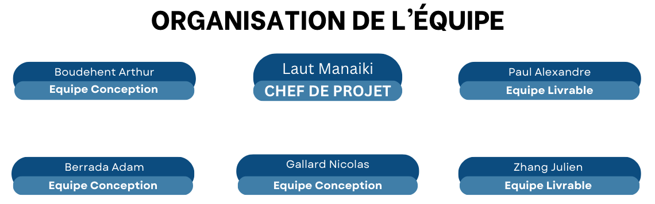

WBS Diagram
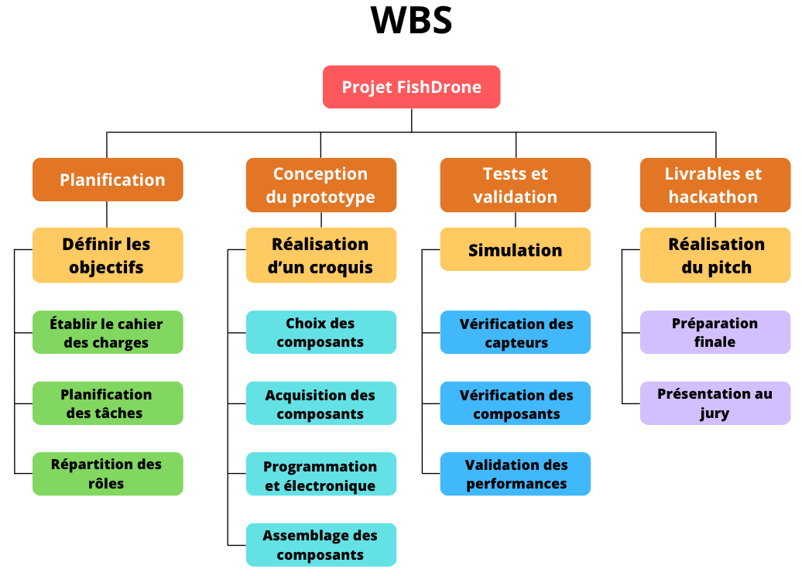

OBS Diagram
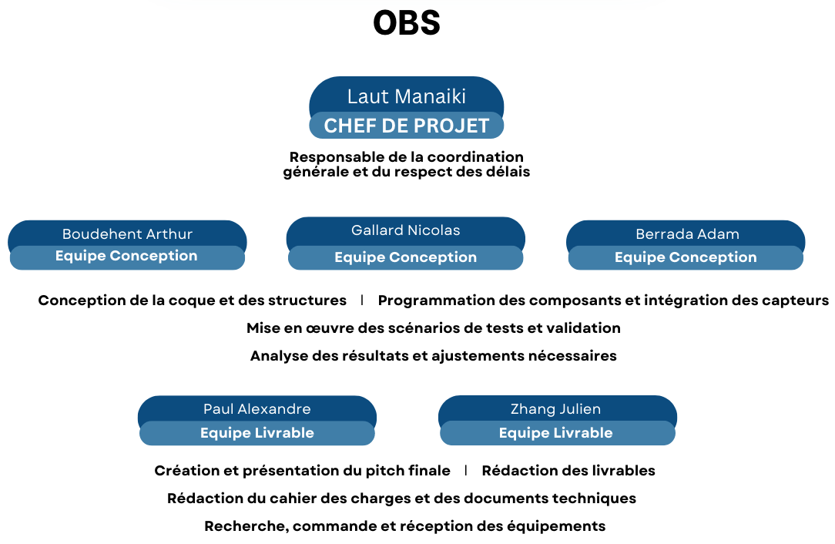

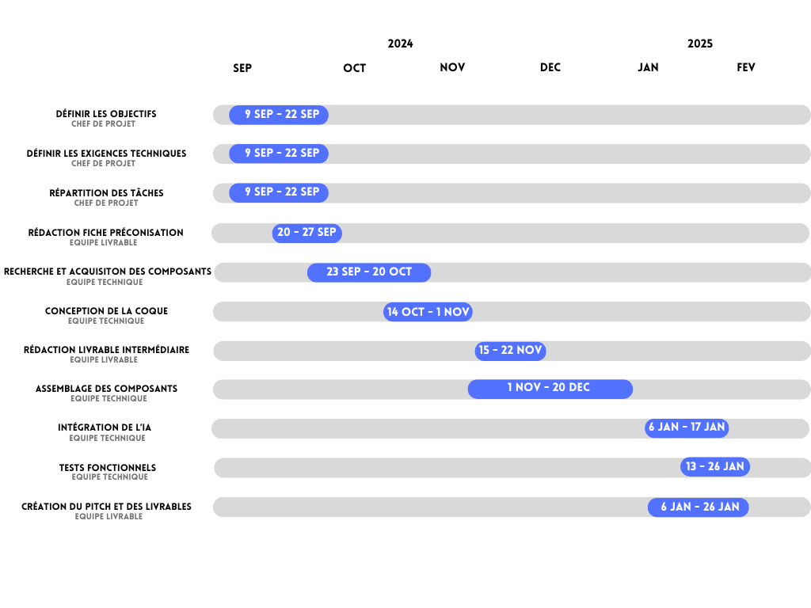
Gantt Chart

2. Hackathon of October 24, 2024

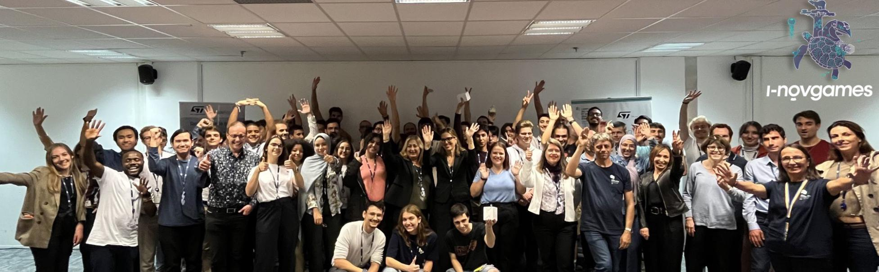
In order to allow different groups to choose their project related to the issue, STMicroelectronics organized a hackathon in Gardanne, gathering all competitors as well as project partners Innov Games. This event was introduced by two major conferences. The first focused on the operation of the Innov Games, the STM32 boards provided, and recent technological advances, specifically the H7 series. The latter, used in our project, stands out for its advanced data processing capabilities, notably allowing image recognition through artificial intelligence. The second conference addressed crucial biodiversity issues, whether current or future, highlighting the challenges to be met and the opportunities offered by new technologies to protect our planet.
These conferences were followed by an interactive session titled Brainstorming Service for Innovation, led by experts in technological solution development. This session allowed us to discover an original method, adopted by STMicroelectronics for its own employees, to cultivate creativity and innovation within teams. This method, based on the concept of brainstorming by opposites, consists of first identifying major problems before proposing possible solutions. Through this exercise, our team was able to refine its thinking and determine a relevant theme for the project: the fight against poaching and illegal fishing, two scourges that seriously threaten biodiversity.
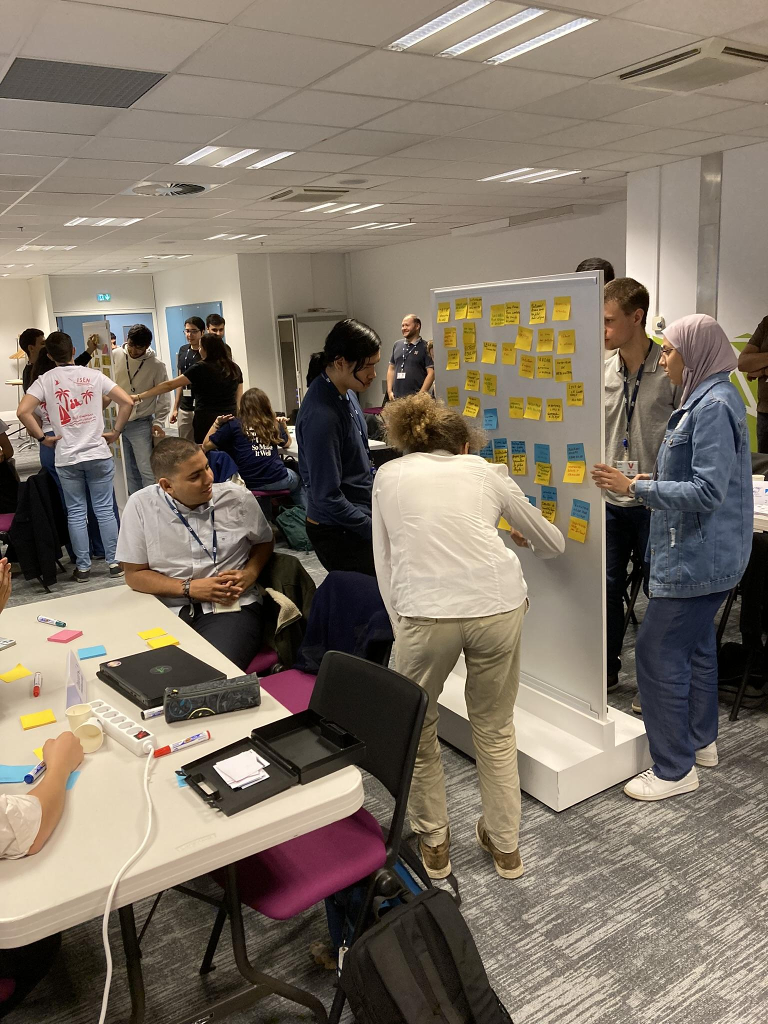
After this reflection phase, participants had the opportunity to visit the ST site facilities in Gardanne, an immersion that offered a fascinating overview of the technologies developed by the company. A generous buffet was also served, encouraging informal exchanges between teams, partners, and the experts present.
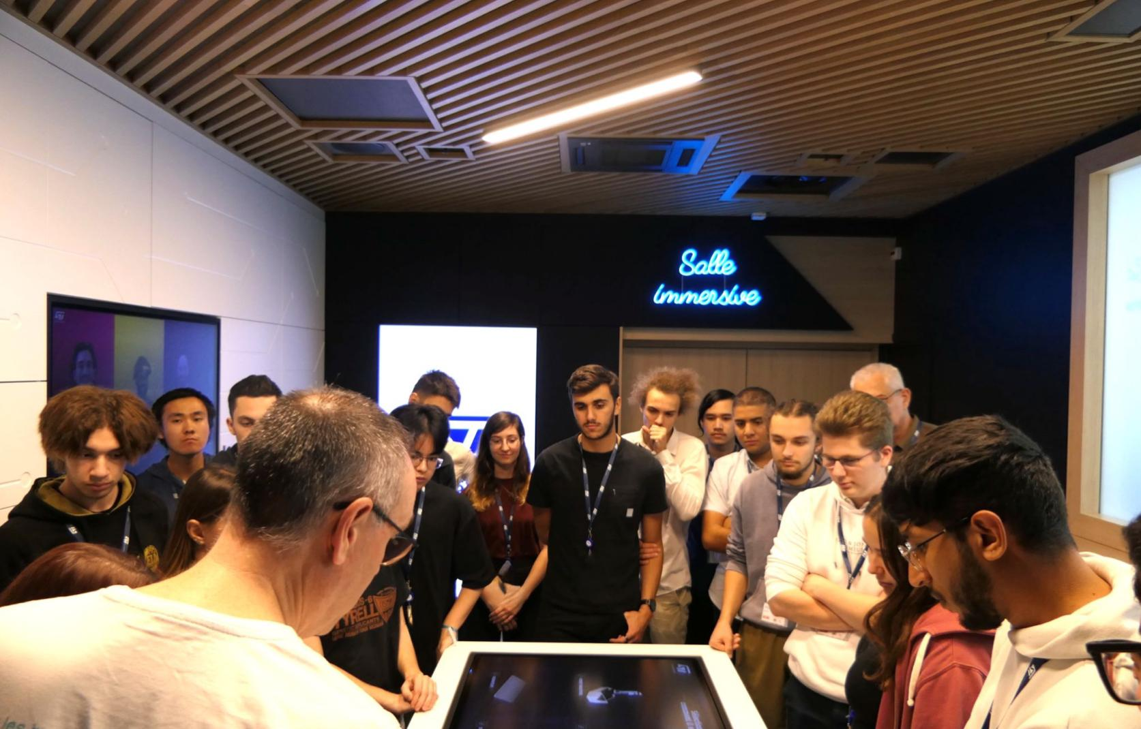
Next, each team drafted a detailed specification, specifying the technical requirements, necessary ST hardware, planned features, as well as the goals and limitations of the project. This document formed a solid basis for preparing a five-minute pitch to present before a jury of experts. This jury was composed of STMicroelectronics teams, guest speakers (including representatives from EDF and the Paul Ricard Oceanographic Institute), as well as biodiversity experts.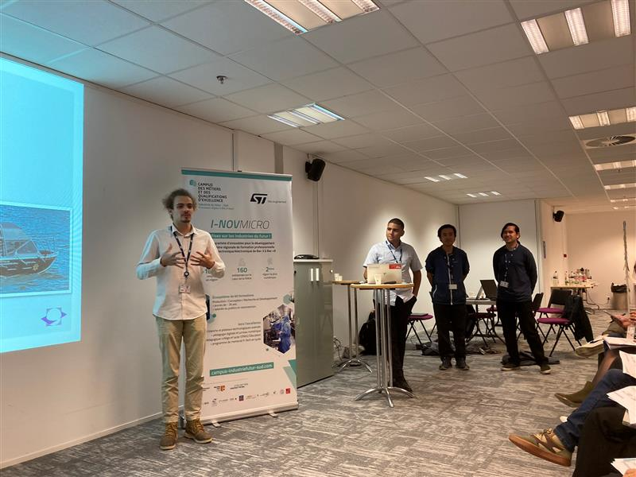
After the presentations, an initial temporary ranking was established. We had the satisfaction of finishing in second position, an encouraging performance that strengthened our motivation. Each team then benefited from an individual exchange time with jury members. These discussions allowed for constructive feedback, whether technical or conceptual, to refine our ideas and perfect our project.
The hackathon thus proved to be an enriching experience, not only for project progress but also for acquiring valuable skills, both technically and humanly. We leave this event with a clearer vision, a strengthened methodology, and above all, a renewed ambition to respond to environmental challenges through technological innovation.

3. Prototype Design
Sketch:

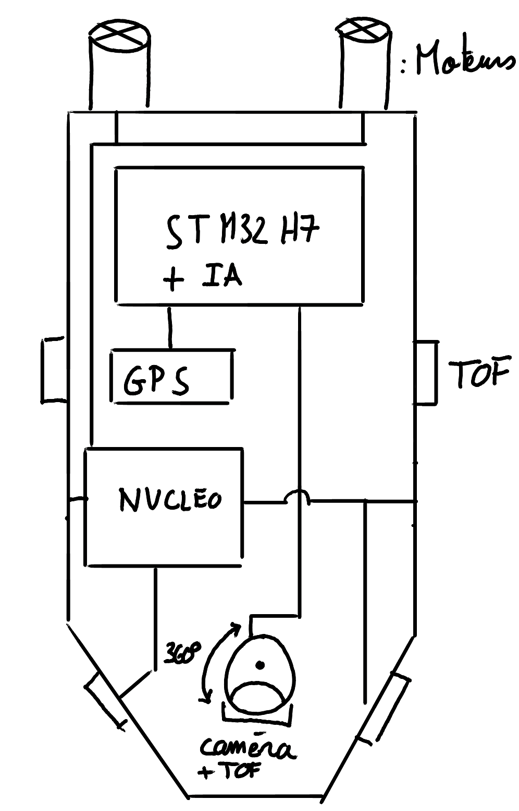

Prototype Operating Principle
The prototype operates through two totally independent parts that allow it to fulfill FishDrone's original missions with the limited time and resources we possess.
The first part is boat movement. It is managed by 4-5 TOF sensors, the motors at the rear of the boat, and a Nucleo board. The operation is quite simple: the Nucleo board waits for a response from the various TOF sensors positioned at different locations on the boat. Depending on their responses, the boat will perform a movement to move away from the detected object to prevent a collision. For example, if the right-side TOF sensors measure a distance of 2 meters while the left-side sensors measure no distance or a distance greater than 8 meters, then the boat will move its right motor for a certain time T to be able to turn left. It is important to understand that this system was designed for navigating on the high seas and is not at all adapted for navigating in tight spaces.

The second part corresponds to boat recognition and detection. It is managed by a GPS module, a camera, and a TOF sensor on the same servomotor axis, as well as by the STM32H7 board with an AI installed inside. To avoid losing time on the data communication part and focus on the microcontroller and its modules, all recovered data will be transmitted to an SD card. The operation of this part is a bit more complex. First, the servomotor that has the camera as well as the TOF sensor on its axis rotates continuously; this allows for mechanically simulating a radar. Then, when the TOF sensor detects something at 8 meters or less, the STM32H7 board will stop the servomotor rotation and activate the camera, which will take either an image or a video of the detected object. If the AI detects that the image contains a boat, it will save the image or video in question as well as its GPS coordinates on the SD card; otherwise, it does nothing. Between each detection of an object by this system, there will be a waiting time before repeating the object detection operation. For the prototype demonstration on competition day, an LED will be added to indicate whether the boat has saved data or not.

Equipment List
- Camera with 1 servomotor
- GPS for position control
- Radar for boat detection at very long range (simulated by a servomotor and a TOF sensor)
- 4-5 TOF sensors for obstacle avoidance
- 2 propeller motors to steer the boat
- Battery
- Structure, sheet metal hull (student design)
All these elements will be connected to a high-performance STM32 (H7) board, allowing data transmission and boat detection thanks to AI, and a Nucleo board to manage boat movements. FishDrone is also capable of going into standby mode to optimize its autonomy: in standby mode, only the radar (in low-power mode) and the TOF sensors are activated, waiting for detection.
Component Choices:
Sensors for long-distance boat detection:
- Radar: Essential for maritime navigation, radar allows for detecting objects over wide perimeters, up to several tens of kilometers. It identifies not only boats but also buoys, reefs, and other obstacles. Radar is particularly effective in bad weather conditions or low visibility. Unlike cameras, which can be limited by low light or fog, radar works in almost all conditions, including rain, fog, and night.
- S-band radar: Less sensitive than X-band radar, it operates at a lower frequency (3 GHz) and is therefore better suited for long distances. This type of radar is ideal for monitoring a vast maritime area.
Sensors for medium-distance obstacle detection:
- X-band radar: Operating at a high frequency (9.41 GHz), it offers very fine resolution, making it excellent for detecting small objects, such as small fishing boats, at short or medium range.
- TOF (Time of Flight) Sensor: Used for precise detection of obstacles at short and medium range.

Equipment References

- TOF (Time of Flight) Sensor: Model VL53L1CB
- Main camera: Models MB1683 or MB1379 (5 Mpx)
- GPS Module: Model TESEO-LIV3F
- STMicroelectronics Boards: Nucleo board (TOF and motor), STM32H7 board (central: AI, servo-camera and servo-TOF)
- Servomotors: Model MG996R (with increasing torque force, 360°)
- Underwater DC Motor : (24V, 29 rpm)
- ESC
- Battery

Hull Design

Value Name | Symbol | Value | Unit
Steel density | ρ_{acier} | 7,8 | kg/dm³
Fiberglass density | ρ_{fibreverre} | 2,6 | kg/dm³
Carbon density | ρ_{fibrecarbone} | 1,8 | kg/dm³
Sea density | ρ_{mer} | 1,0 | kg/dm³
Sea dynamic viscosity | η_{frottement} | 1,50 | N/m/s
Motor power | P | 30-200 | W

Sea Water Dynamic Viscosity
The dynamic viscosity used corresponds to that of the Mediterranean Sea water, characterized by two constant parameters: a temperature of 18°C and a salinity of 35 PSU (Practical Salinity Units). This combination directly influences the hydrodynamic properties of the medium.

Acquisition and Design of the Boat Hull
Two main approaches were considered for the hull's realization:

- Purchase of a pre-existing hull, either empty or requiring extrusion.
- Manufacturing from raw materials, designing the hull entirely.

After thorough theoretical reflection, the second option was chosen. The process consisted of:
- Procuring a metal plate with dimensions 1000 × 600 × 1.5 mm.
- Cutting the plate according to pre-established plans.
- Bending the components at specific angles to obtain the desired shape.
- Welding the pieces to ensure hull watertightness.

Material Considerations
Although steel was chosen for this project, other materials, such as fiberglass or carbon fiber, would have been ideal to reduce hull weight while improving aerodynamic performance. Using these materials would also have allowed taking advantage of molds to obtain a more optimized shape. However, time and budget constraints made steel more accessible despite its relatively high mass.

Description of Drawings
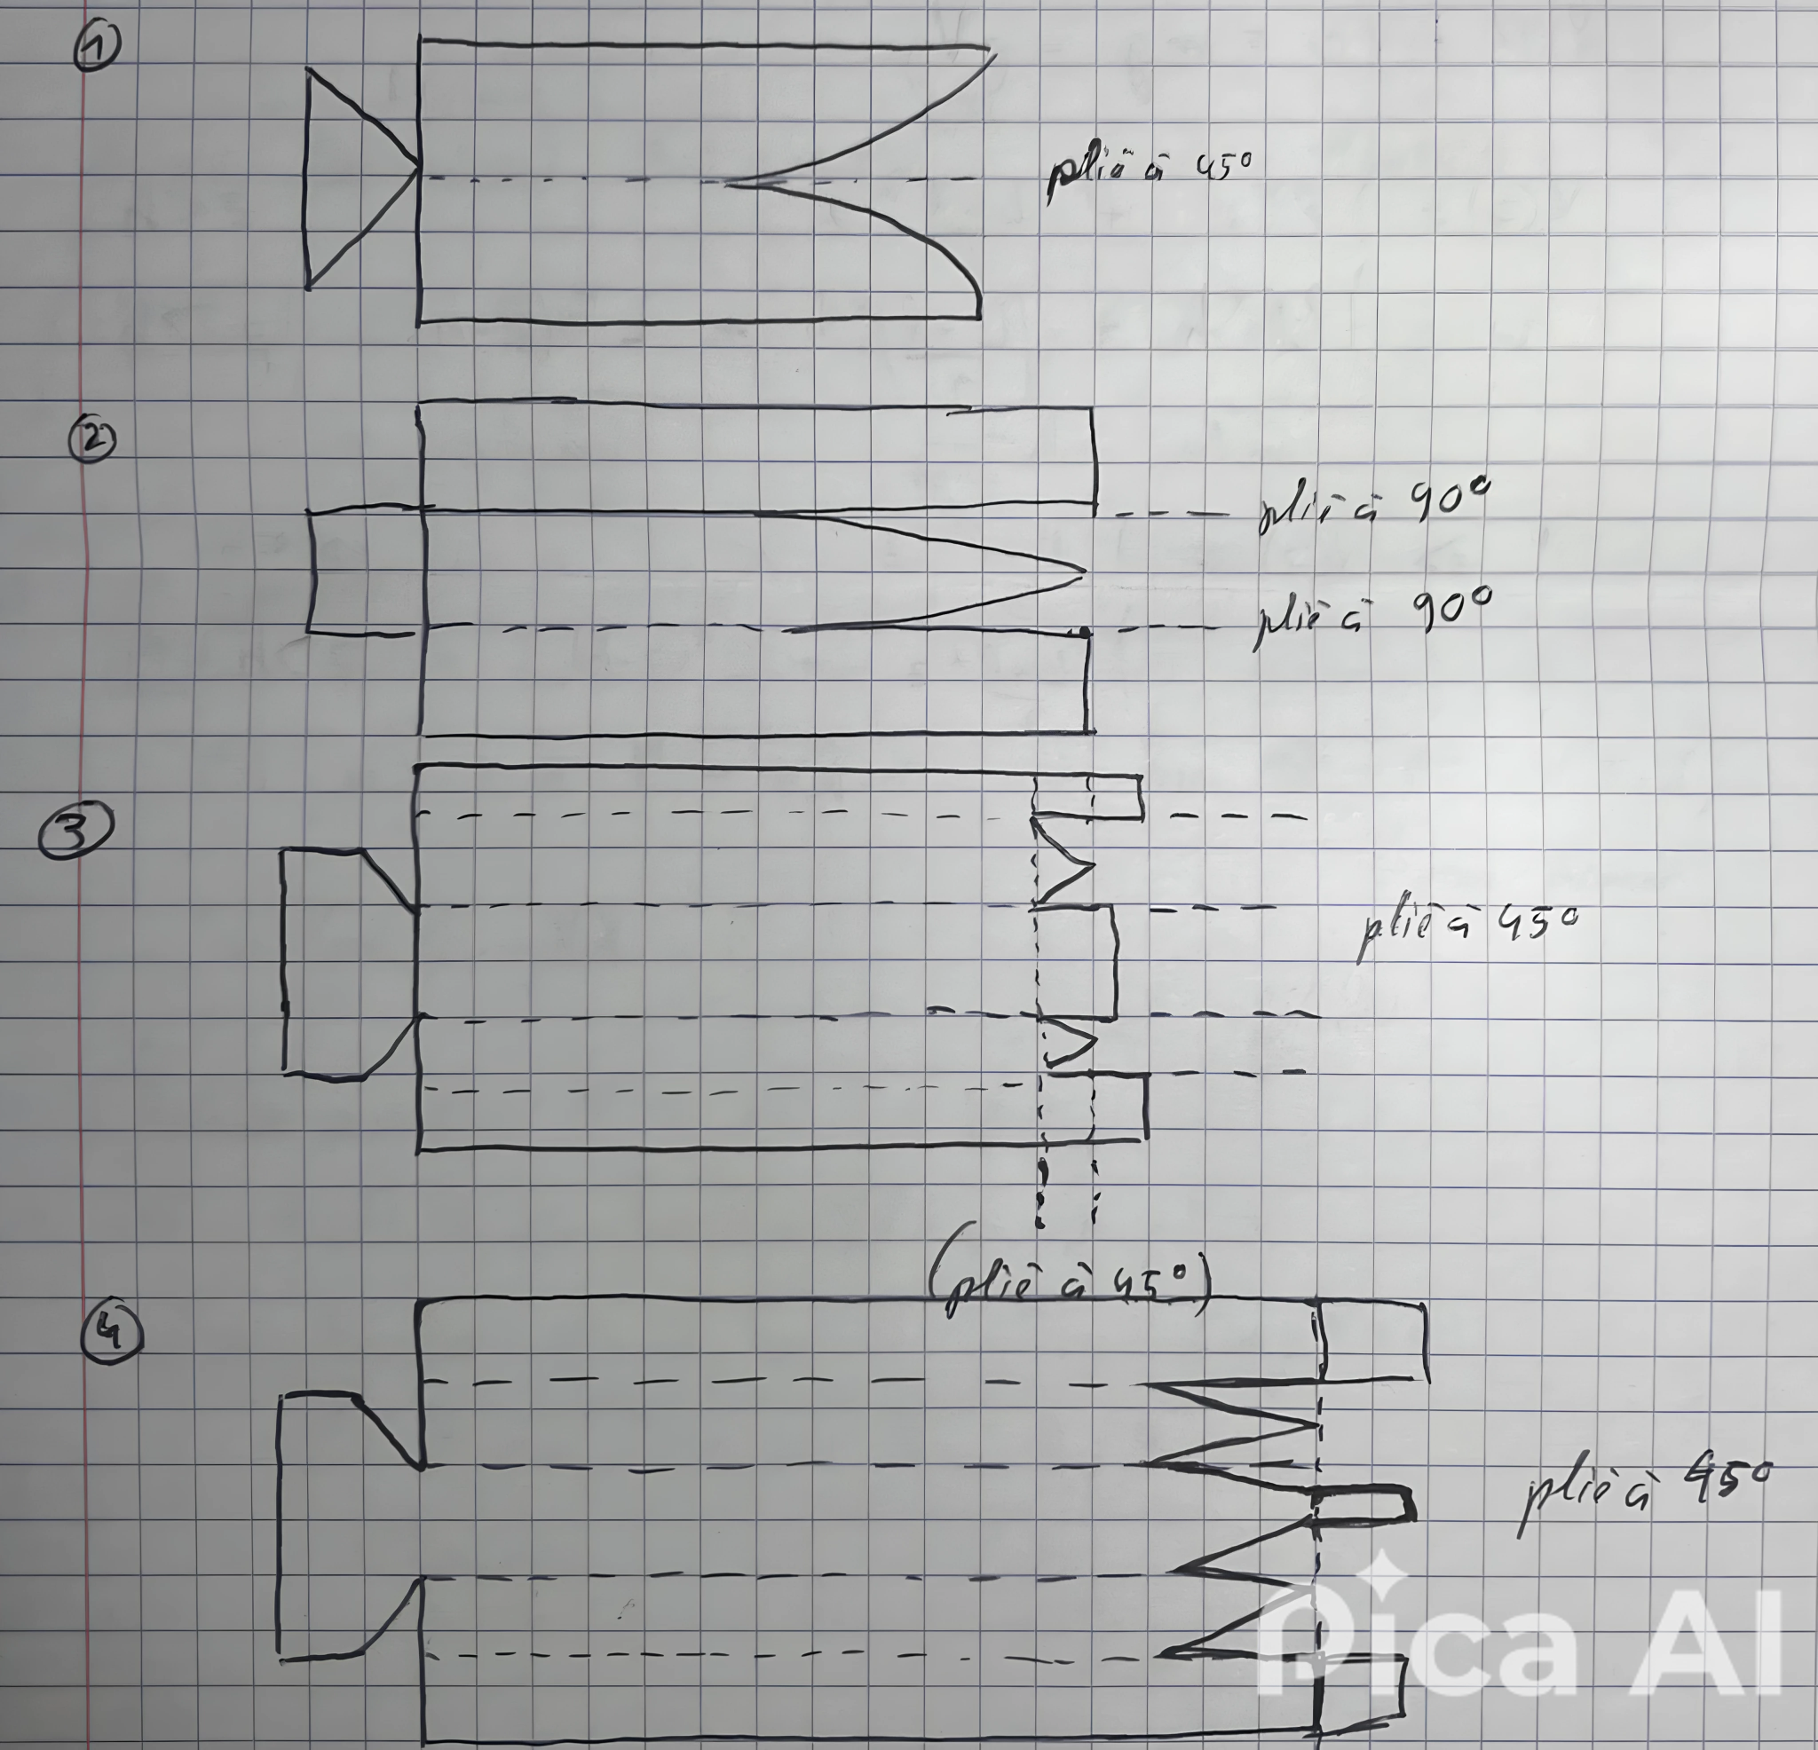
Hull Design Guideline
The hull designs were decomposed into three main parts:
- The rear: A section perpendicular to the sea surface;
- The side: The lateral part that ensures the link between the front and the rear;
- The front: Pointed shape to improve aerodynamics and water penetration.
Since the hull is made of metal, certain procedures specific to wooden hulls, such as complex stern design or intensive waterproofing, are not necessary.
Design Evolution
The proposed designs were schematized and classified from least evolved to most evolved (schemas 1 to 4):
Schema 1:
- This design is the simplest and fastest to realize;
- The hull is triangular in shape, but it has poor angular stability because its center of gravity is relatively high due to its dimensions.
Schema 2:
- An attempt is made to reduce the center of gravity height, but the proposed cubic shape is not realistic with the selected dimensions.
Schema 3:
- The side, initially perpendicular to the water surface, is decomposed into two folds inclined at 45°;
- Although this design improves stability and internal space, the pointed front remains unusable.
Schema 4:
- This design corrects the defects of the previous one by creating a point at the front;
- It offers enough space inside the hull to integrate computer components while maintaining a relatively low center of gravity, which significantly improves stability.

Motor Power
By applying the Fundamental Principle of Dynamics to the {boat} system in the terrestrial frame of reference assumed to be Galilean and projecting onto the boat's axis of movement, we can take into account only the boat's friction force.
Hypothesis: we neglect the angle that the boat will develop backwards upon motor activation.
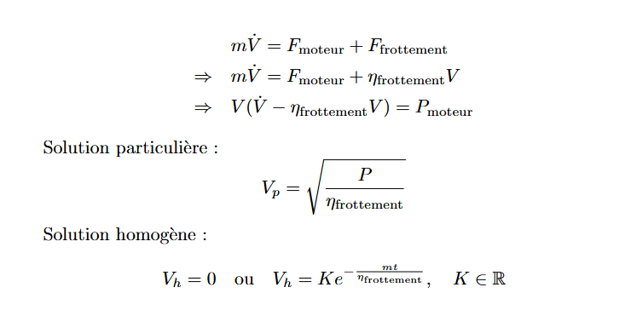

Physics at Rest / Boat Buoyancy
Hypothesis: we can neglect and compensate for the internal volume of the point by prolonging the length of the internal shape of the hull.
Data:
- h is the distance between the bottom of the boat hull and the point where the hull inclination no longer needs to be taken into account;
- z is the distance between the hull bottom and the sea surface.
By applying the fundamental principle of dynamics at equilibrium to the {boat} system in the terrestrial frame of reference assumed to be Galilean, and projecting onto the axis perpendicular to the boat's plane of movement, we can retain the force of gravity as well as the Archimedes' thrust force.
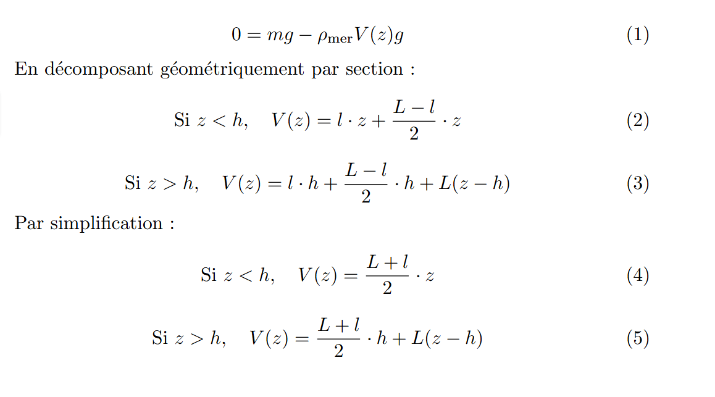
Angular Stability
The angular momentum theorem allows us to obtain an equation characterized by the resistance to angular friction of the boat hull, and Archimedes' thrust. This gives us a quantification of the boat's quality to right itself if it undergoes an initial inclination of less than 10 degrees.
Concepts
Hypothesis: We study the effect of the force of gravity and Archimedes' thrust.
- Center of gravity (G)
A low center of gravity allows for better stability.
- Center of buoyancy (B)
The center of buoyancy is the point of application of Archimedes' thrust. The position of the center of buoyancy changes when the boat inclines, because the level line is no longer perpendicular with respect to the boat's facades.
- Metacenter (Z)
The metacenter is a geometric point located above the center of buoyancy. It represents the intersection of the verticals passing through the center of buoyancy when the boat is inclined. The distance between the center of gravity (G) and the metacenter (Z), called metacentric height (GZ), is a key indicator of stability. It can be interpreted as the lever arm caused by the interaction between the center of gravity and Archimedes' thrust.

We have selected two approaches to study angular friction. The first is a computer modeling of the system by discretizing the hull surface to make it interact with its environment. The second is modeling the system as a simple pendulum, with a friction coefficient proportional to speed.
Equation of Motion
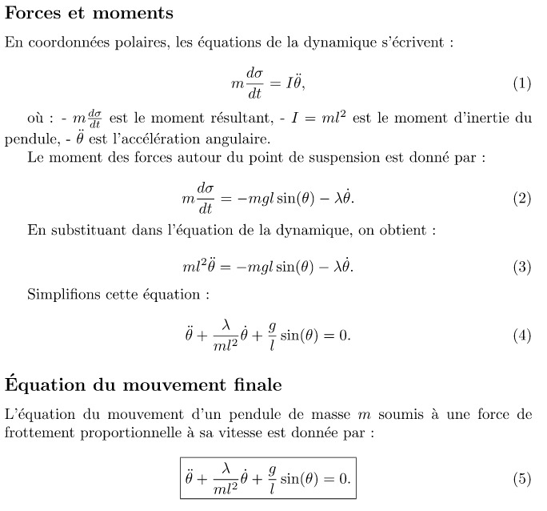

Computer Modeling

import numpy as np
import matplotlib.pyplot as plt
from scipy.integrate import solve_ivp
#Données
m=6 #masse, kg
l=0.8 #longueur caractéristique, m
eta=1.5 #frottement fluide
a = eta/(m*l**2) #1er coefficient de l'Équation du mouvement
b = 9.81/l #2ème coefficient de l'Équation du mouvement
# Équation du mouvement
def system(t, Y, a, b):
y, z = Y # Y[0] = y, Y[1] = y'
dydt = z
dzdt = -a * z - b * np.sin(y)
return [dydt, dzdt]
#Domaine d'étude temporelle
t_span = (0, 20)
#Condition initiale
y0 = [10 * np.pi / 180, 0]
#Résolution du problème
solution = solve_ivp(system, t_span, y0, args=(a, b), t_eval=np.linspace(t_span[0], t_span[1], 500))
t_values = solution.t
y_values = solution.y[0]
#Conversion radien en degré
y_values_deg =y_values * 180 / np.pi
#Affichage du résultat
plt.plot(t_values, y_values_deg)
plt.title("Réponse du bateau à une inclinaison de 10 degrés")
plt.xlabel("Temps (s)")
plt.ylabel("theta (°)")
plt.grid(True)
plt.legend()
plt.show()

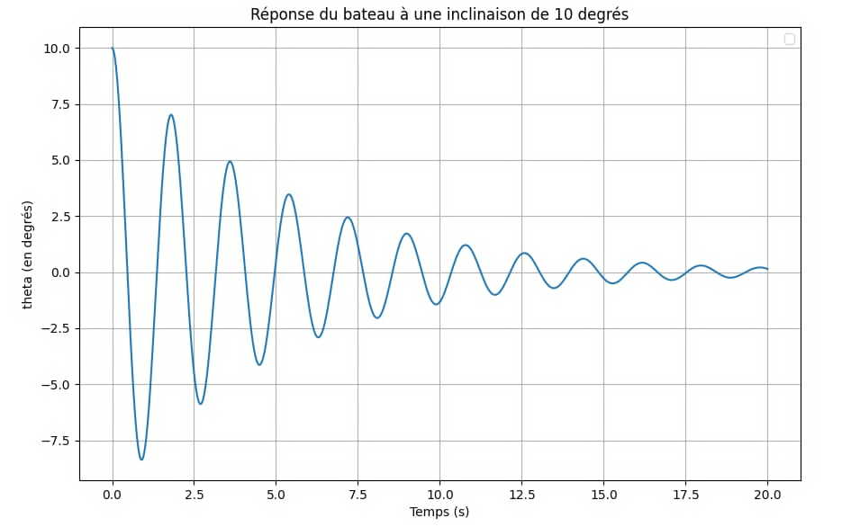
We will retain from this computer modeling the value of t = 15s, for the boat to have an inclination of less than 1° for an initial inclination of 10°.

AI for Boat Recognition

To implement this recognition system, we used the PyTorch tool with a pre-trained model (Faster R-CNN) on a pre-existing database, as well as cv2 to be able to have a video rendering on a computer of the robot's vision. Here is a computer example of the model.
import torch
import torchvision.transforms as T
from torchvision.models.detection import fasterrcnn_resnet50_fpn
import cv2
device = torch.device('cuda' if torch.cuda.is_available() else 'cpu')
print(f"Using device: {device}")
model = fasterrcnn_resnet50_fpn(pretrained=True)
model.eval()
model = model.to(device)
print(next(model.parameters()).device)
COCO_CLASSES = [
"__background__", "person", "bicycle", "car", "motorcycle", "airplane", "bus",
"train", "truck", "boat", "traffic light", "fire hydrant", "stop sign",
]
video_path = "input_video1.mp4"
output_path = "output_video.avi"
cap = cv2.VideoCapture(video_path)
fourcc = cv2.VideoWriter_fourcc(*'XVID')
out = cv2.VideoWriter(output_path, fourcc, 20.0,
(int(cap.get(3)), int(cap.get(4))))
transform = T.Compose([
T.ToTensor()
])
while cap.isOpened():
ret, frame = cap.read()
if not ret:
break
img_tensor = transform(frame).unsqueeze(
0).to(device)
with torch.no_grad():
predictions = model(img_tensor)
boxes = predictions[0]['boxes']
labels = predictions[0]['labels']
scores = predictions[0]['scores']
for box, label, score in zip(boxes, labels, scores):
if label < len(COCO_CLASSES) and COCO_CLASSES[label] == "boat" and score > 0.6:
x1, y1, x2, y2 = map(int, box)
cv2.rectangle(frame, (x1, y1), (x2, y2), (0, 255, 0), 2)
cv2.putText(frame, f"Boat: {score:.2f}", (x1, y1 - 10),
cv2.FONT_HERSHEY_SIMPLEX, 0.5, (0, 255, 0), 2)
if label < len(COCO_CLASSES) and COCO_CLASSES[label] == "person" and score > 0.6:
x1, y1, x2, y2 = map(int, box)
cv2.rectangle(frame, (x1, y1), (x2, y2), (0, 0, 255), 2)
cv2.putText(frame, f"Person: {score:.2f}", (x1, y1 - 10),
cv2.FONT_HERSHEY_SIMPLEX, 0.5, (0, 0, 255), 2)
out.write(frame)
cv2.imshow('Frame', frame)
if cv2.waitKey(1) & 0xFF == ord('q'):
break
cap.release()
out.release()
cv2.destroyAllWindows()

Code Result:
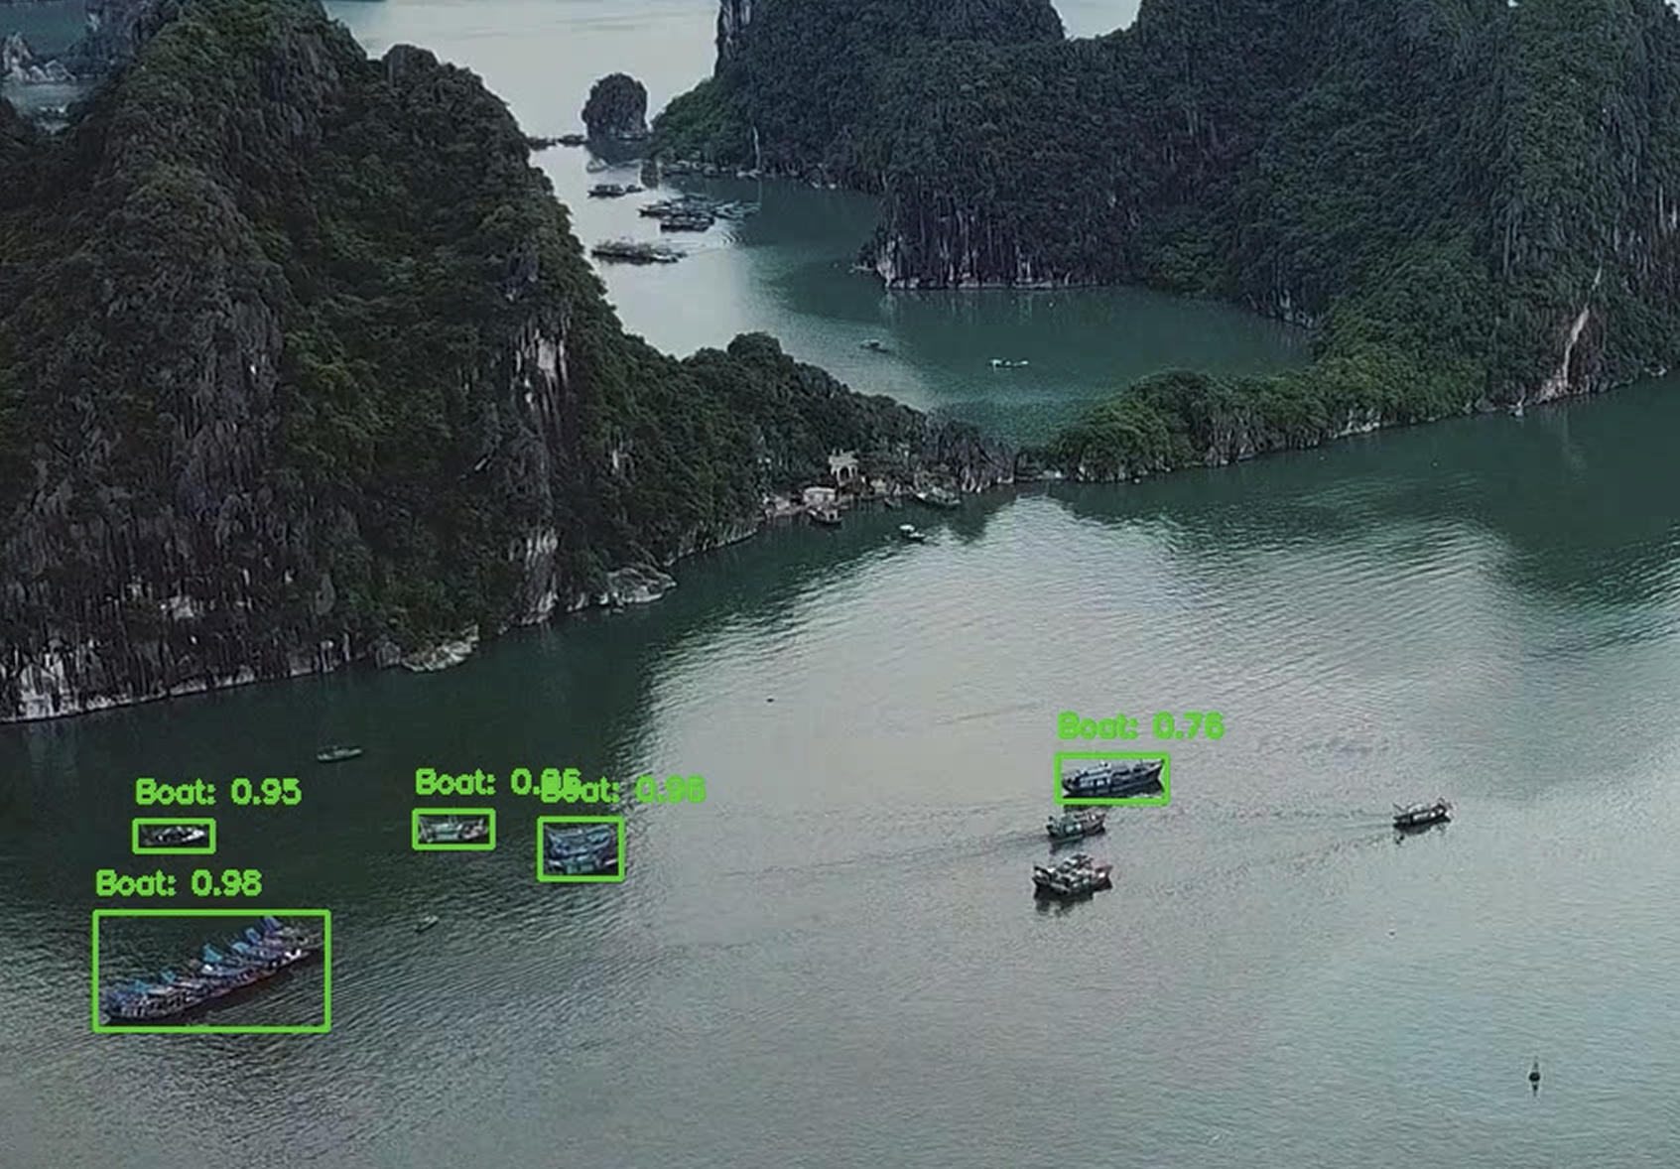
As can be seen, the model successfully detects boats, but not all of them. It is therefore necessary to enrich the existing database with images of boats if better results are desired. Unfortunately, we do not have a large database of boat images, which makes its improvement rather complex.

To transmit this code to the ST board, it is necessary to use the ST IDE or their online model installation tool. The tutorial followed for this step was: AI in STM32.

4. Principle of Boat Recognition

Boat recognition in real life relies on several visual and contextual characteristics:
- Silhouette and general characteristics.
This notably includes hull shape, structure height, and the presence or absence of masts and chimneys. These traits first allow for distinguishing the type of vessel, such as cargo ships, tankers, or sailboats.
- Markings and identification.
A feature visible at long range is color, which provides additional information (boat origin, company, affiliation). Lettering is visible at close range and informs us primarily about the company name.
- Light signals. An element that plays an essential role in navigation and for nighttime identification.
- Architectural details. Elements like crane layout and mast style provide additional information to refine recognition.
- Human experience. Finally, recognition also relies on the expertise of sailors and professionals who can observe subtleties linked to their own experience.

